SciX – Cognitive Science

Week 1 (Nov 25-29)

* Follow these three links to complete 2 cognitive psychology experiments and 1 questionnaire
* For experiment 1 – a csv (excel) file should download automatically, **make sure to save that file as we will use this file in Week 2**
* Answer the questions to each experiment/questionnaire
* Experiment 1: <https://expfactory-experiments.github.io/flanker/> (10 mins – 12 practice trials and 100 test trials)
  1. How did you find this task? Fun? Easy? Hard?
  2. Were some trials more difficult than others? If so, which one’s did you find harder? Do you have any predictions why?
  3. What happens if you don’t respond fast enough (you can go back and test it out and click Esc to exit after a couple of trials)? Why do you think the study is programmed this way?
  4. Look over the excel sheet and try to understand as much as you can
     + are you surprised by how long the data file is?
     + Find the column that says “condition” – what are the two conditions? What do you think they mean?
     + What other questions do you have on this file?
* Experiment 2: <https://expfactory-experiments.github.io/cognitive-reflection-survey/> (5 mins – 6 questions)
  1. Did you think these questions were easy or difficult?
  2. How many questions do you think you answered correctly (out of 6)?
  3. What do you think the purpose of this task is? What are researchers potentially interested in observing?
* Questionnaire: <https://expfactory-experiments.github.io/bis11-survey/> (5 mins – 30 questions)
  1. At the start of this study you saw a screen that said, “People differ in the ways they act and think in different situation. This is a test to measure some of the ways in which you act and think…” – What do you think this questionnaire is trying to measure?
  2. Have you ever taken any sort of personality test or questionnaire? If so, please describe
  3. Why can personality tests or questionnaires like this one important to study?

Week 2 (Dec 2-6): Jamovi – the program we will be learning and using to conduct our data analyses

**Jamovi – instructions for downloading**

1. Go to <https://www.jamovi.org/>
2. Click download
3. Select either the Windows or macOS (solid) to download (may take several minutes)
4. Open Jamovi
5. If you have any trouble – follow the instructions below and watch the second tutorial on “Installing jamovi”
6. *note before moving on* please do not worry if you have never used or heard of “jamovi” or “R” or “SPSS” before

**Jamovi – understanding the basics**

1. Go to <https://datalab.cc/tools/jamovi>
2. Read the homepage and watch the 1:25 min Welcome video
3. 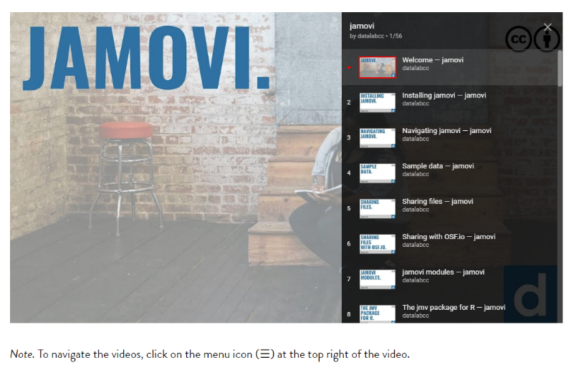In the top right corner of the video, there’s a menu button that allows you to navigate through different tutorials
4. These tutorials cover a lot of material and information. The purpose of watching these videos is just to familiarize yourself with Jamovi, so don’t worry about remembering everything
5. Watch **“Navigating jamovi”** - please do not worry if you don’t understand all of the different types of analyses! We will work through the analyses we need together in the summer school
6. Watch **“Sample data”**
7. Big 5 dataset activity:
   * If you are unfamiliar with the Big 5 Personality traits, watch this short youtube video: <https://www.youtube.com/watch?v=oWpRKJPCI7M>
   * Open up the Big 5 dataset on your own computer/laptop (you can re-watch the tutorial to remind you)
   * Notice how each column is one of the 5 personality traits
   * Navigate to Exploration --- Descriptives: you will see a new panel labelled “Descriptives” pops up
   * Let’s look at Openness and Agreeableness
   * 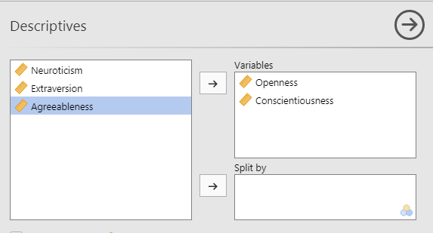Move these two over to the selected variables (by either clicking the arrow or selecting the variable and dragging it over)
   * Now you should see descriptive statistics in a 3rd panel on the right
     1. What is the mean score for Openness? (3.59)
     2. What is the median score for Agreeableness? (3.45)
   * 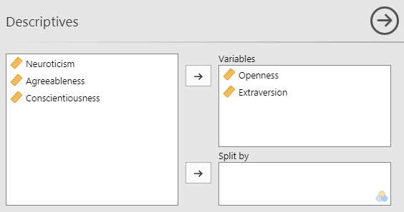Move Agreeableness back and replace it with Extraversion
     1. What is the mean score of Extraversion? (3.49)
   * Still looking at Openness and Extraversion, click on the “Plots” dropdown and check “histogram”
   * This will show you the distribution of people’s scores
   * Feel free to click and play around with different variables or types of plots!
   * Save your work
   * See how easy it is to calculate descriptive statistics and get information quickly on different variables
8. Flanker dataset activity:
   * Last week, you had the chance to complete the Flanker Task (Experiment 1) and you should have saved the csv file
   * Now, we are going to open up the data file in jamovi
   * In a new jamovi window, open up the csv file (you’ll have to browse for it on your computer wherever you have it saved)
   * **The first question we’ll explore is: are you more accurate with compatible (congruent) or incompatible (incongruent) trials?** 
     1. Navigate to Exploration --- Descriptives
     2. We are interested in 2 variables: correct (accuracy) and condition
     3. Our dependent variable is correct, so move that into the variables box
     4. N = 112. This shows us how many trials we completed (12 practice and 100 test) Next, we want to split the data by condition. Now we see that there are 56 compatible trials and 56 incompatible trials.

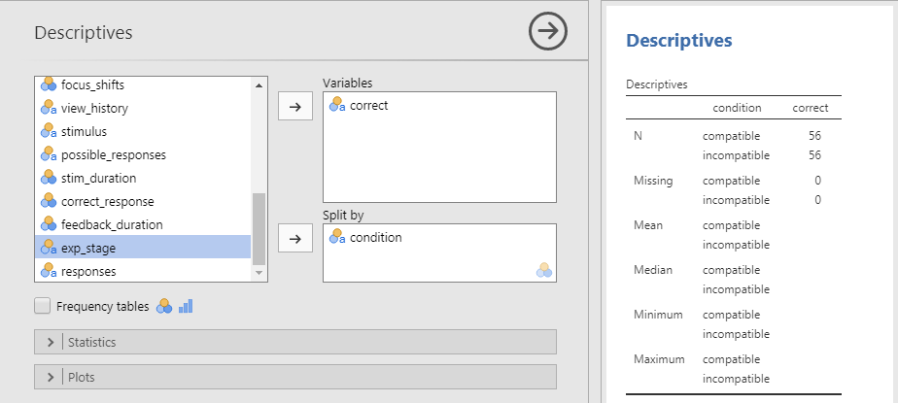

* + 1. 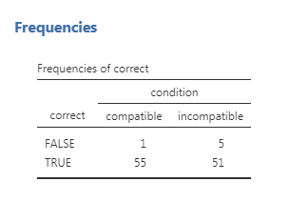Finally, check Frequency tables. This shows you how many compatible trials you got correct and incorrect and how many incompatible trials you got correct and incorrect. Here are my results (yours will of course be different)
    2. So, I got 55 compatible trials correct and 51 incompatible trials correct
    3. How many compatible trials did you get correct?
    4. How many incompatible trials did you get correct?
    5. Save your work
  + **The second question we’ll explore is: are you faster responding to compatible or incompatible trials?**
    1. To do this we’ll need to explore the RT variable – this stands for Reaction (or response) Time. So how long does it take you to make each decision
    2. Again, navigate to Exploration --- Descriptives
    3. Rather than looking at correct, now we are interested in looking at RTs
    4. 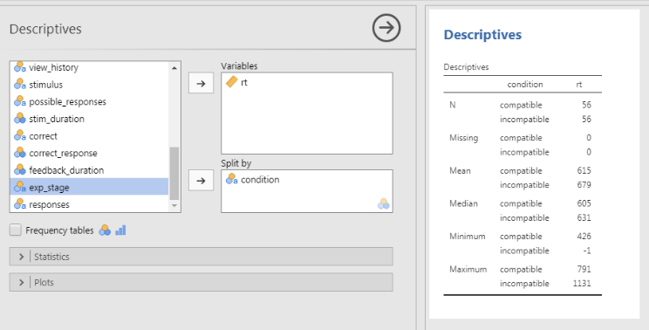So move rt into the Variables box and again split by condition
    5. I can see that my mean rt for compatible trials is 615 and my mean rt for incompatible trials is slightly longer at 679
    6. What are your mean rts for compatible trials?
    7. What are your mean rts for incompatible trials?

Week 3 (Dec 9-13)

* Go through and complete the full experiment that we will be collecting data for during the summer school
* Pay attention to which tasks and/or questions you think are particularly interesting, so you can begin thinking and generating possible hypotheses
* Link to the experiment: <http://scix-experiment.psy.unsw.edu.au/> (should take approximately 30 minutes)
* The rest TBD
* Some ideas:
  + Readings? TED talks? Replication crisis?
  + <https://theconversation.com/mapping-the-brain-scientists-define-180-distinct-regions-but-what-now-62972>

Initial Hypotheses Due before Summer Holiday